TASK | Application of Flawfinder developer Spray to fork lift trucks
LOCATION OF USE | Workshop and on Client sites |  | Assessment  No |  | 036
PRODUCT NAME | FLAWFINDER DEVELOPER SPRAY
DESCRIPTION OF SUBSTANCE | Developer
MANUFACTURER | Rocol
MANUFACTURERS CONTACT | ROCOL House  Swillington  Leeds  West Yorkshire  LS26 8BS  ENGLAND  Tel: +44 (0) 113 232 2700  Fax: +44 (0) 113 232 2740
ASSESSOR | Martin Monaghan CMIOSH |  | Date |  | 04/12/25
TITLE | Health and Safety Consultant |  | Review by |  | 04/12/27
Personnel Performing Task  (Please list below)  Technicians/ Fitters/ Workshop Operatives |  | Time Spent  (Minutes/day)  As and when required, amounting to a few minutes per day | Training Given 
 |  |  | Yes

MSDS Revision Date | Hazard Statement
19 07 2006 Rev:3 | Extremely flammable.  Irritating to eyes.  Vapours may cause drowsiness and dizziness.

Assessment to be conducted in Association with Hazard Data Sheets, a full current copy of which must be attached to this assessment.

Please denote the hazardous properties of the substances used in the task with a 

NEW INTERNATIONAL GLOBALLY HARMONISED HAZARD SYMBOLS
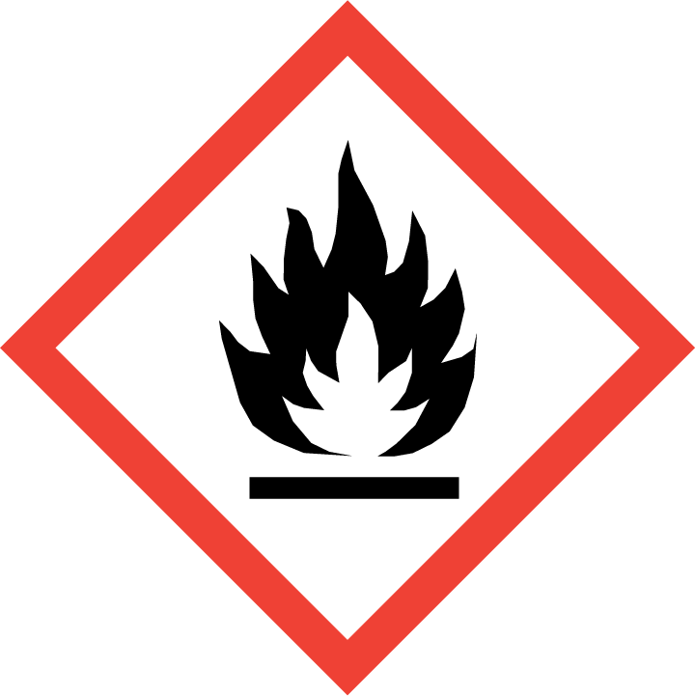 | 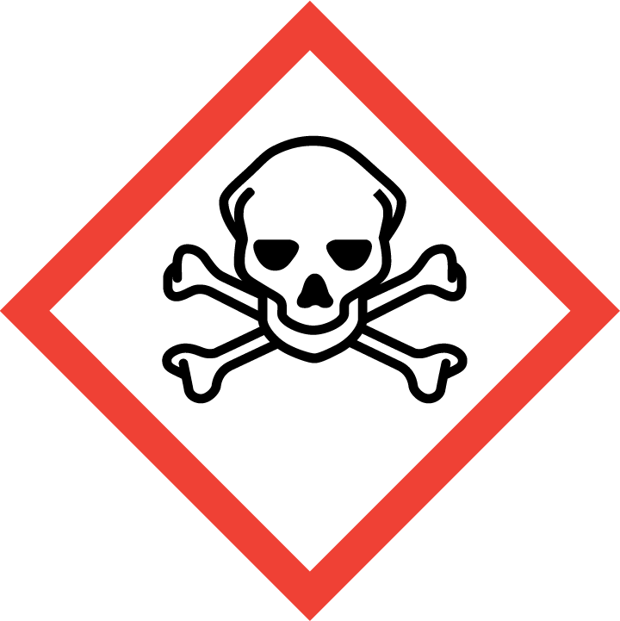 |  | 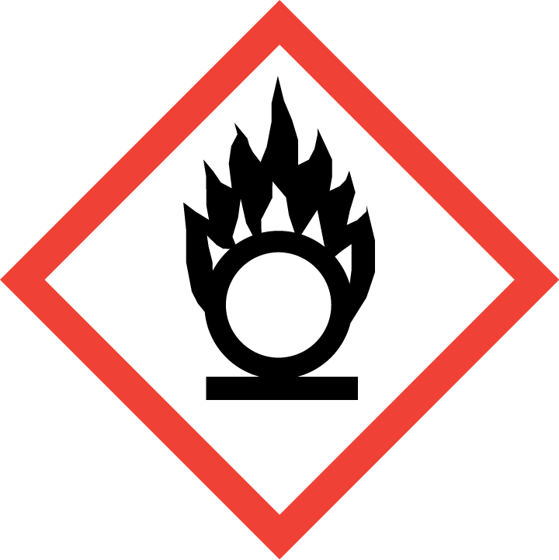 | 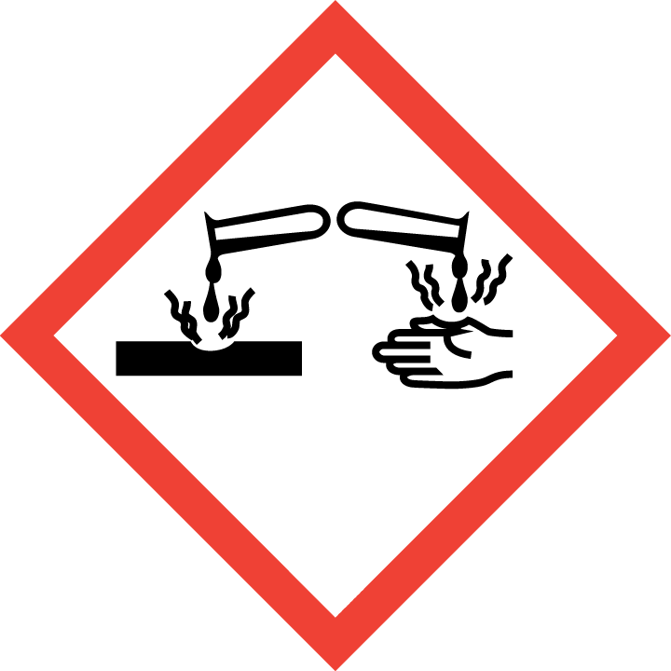 | 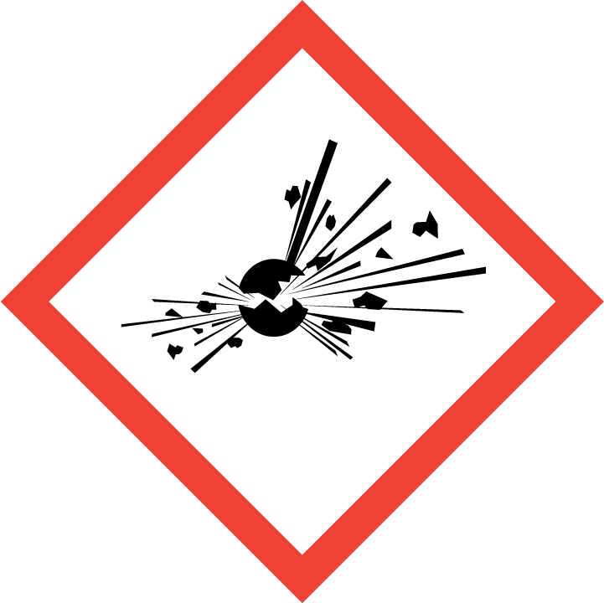 | 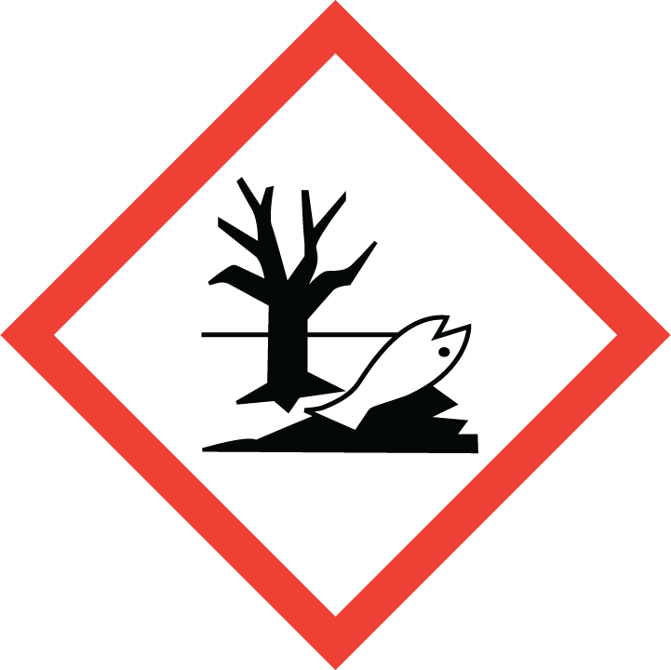 | 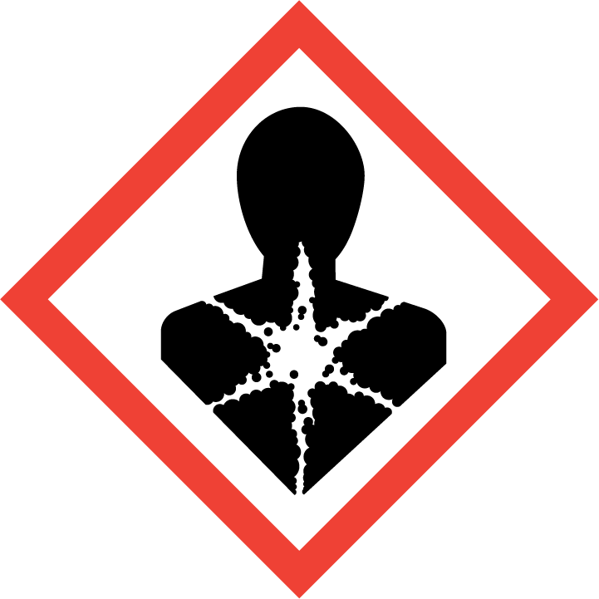
Flammable | Toxic | Harmful | Oxidising | Corrosive | Explosive | Harmful to the environment | Health Hazards i.e. respiratory sensitisation or carcinogenicity
 |  |  |  |  |  | 

SMOKING, EATING AND DRINKING ARE PROHIBITED IN THE WORK AREAS.
Information, Instruction and Training must be provided to all users. Young Persons, New or Expectant Mothers and other vulnerable groups must not use or be exposed to this product.

WORKPLACE EXPOSURE LIMITS (WEL’s)
No WEL applicable for product.

IMPORTANT!
Refer to Workplace Exposure Levels information provided in the Manufacturers Safety Data and revise control measures if exposure levels likely to be reached.

ROUTE OF EXPOSURE
Skin |  | Eyes |  | Inhalation | 
Ingestion |  | Cuts/abrasions |  | Systemic

PERSONS AT RISK
User of product |  | Co workers |  | Members of the public

ROUTE OF EXPOSURE |   FIRST AID MEASURES
Eyes | Bathe the eye with running water for 15 minutes. Consult a doctor.
Skin | Wash immediately with plenty of soap and water. Consult a doctor.
Inhalation | Remove casualty from exposure ensuring one's own safety whilst doing so.
Ingestion | Wash out mouth with water. Do not induce vomiting. Consult a Doctor.
In all cases of doubt, or if symptoms persist seek medical attention. Never give anything by mouth to an unconscious person. If unconscious, place in recovery position and seek medical advice.

PERSONAL PROTECTIVE EQUIPMENT
 |  |  |  | 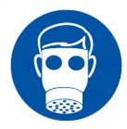 |  | 
YES | YES |  | YES/NO | YES/NO | YES | YES/NO
YES | YES |  |  |  | YES - Chemical Resistant

HANDLING | STORAGE | TRANSPORT | DISPOSAL
Ensure there is sufficient ventilation of the area. Do not handle in a confined space.  Smoking is forbidden. | Store in a cool, well ventilated area. Keep away from sources of ignition. Keep away from direct sunlight. | Only carry minimum required amounts at any one time. Carry secured upright within the vehicle away from direct sunlight and sources of ignition. | Dispose of waste and residues in accordance with local authority requirements.

REQUIRED CONTROL MEASURES
- Ensure only minimum amounts are transported and used (1 can).
- Ensure approved nitrile, neoprene or PVA gloves are worn when using substance.
- Ensure overalls are worn and these are suitably laundered.
- Ensure suitable chemical resistant goggles (with side-shields) are worn when spraying cleaner.
- Ensure that work is undertaken in well ventilated areas. Where insufficient natural ventilation is available ensure an approved vapour/particle respirator is used.
- Do not apply near walkways and clear any areas of overspray.
- Ensure that Engineers are equipped with antibacterial hand washes and wipes and that good hygiene practices are enforced.
- Provide engineers with suitable barrier creams.

FIRE PRECAUTIONS
EXTINGUISHING MEDIA – Alcohol resistant foam. Carbon dioxide. Dry chemical powder. Do not use water. Use water spray to cool containers.

ACCIDENTAL RELEASE/SPILLAGE PROCEDURES
PERSONAL PRECAUTIONS
Turn leaking containers leak side up to prevent the escape of liquid. Mark out the contaminated area with signs and prevent access to unauthorised personnel. Wear appropriate PPE
ENVIRONMENTAL PRECAUTIONS
Do not discharge into drains or rivers. Contain the spillage using bunding.

MONITORING REQUIREMENTS AND HEALTH SURVEILLANCE
Health surveillance is not in place for workers exposed to this product.

